- Alarm: ID 22: Rear PLS Alarm
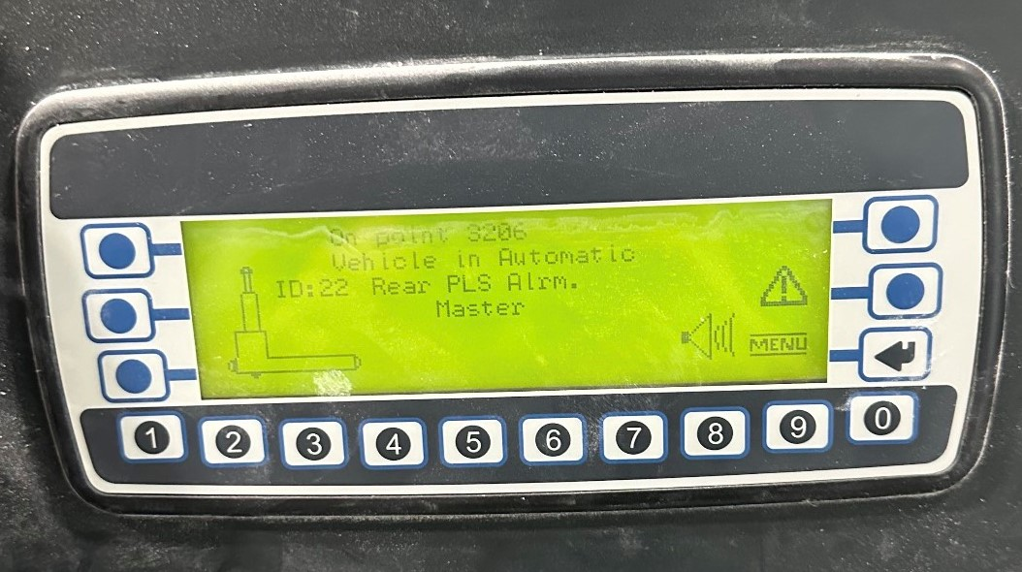
How To Fix:.
Identify the safety zone: The rear sick eye has a safety zone extending 0-18 inches in front of and around it.
Remove any obstruction within this zone.
Any object within this area will trigger the sick eye, causing a safety alert.

